Octahedron
# Source: AI Source: Provided by: [Data Path: Persons Table -> ID Column: 1, Name_En Column: Motasem Essam] -> From: [ChatGPT] on [7/25/2026]
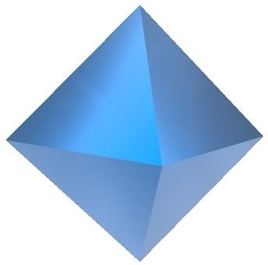
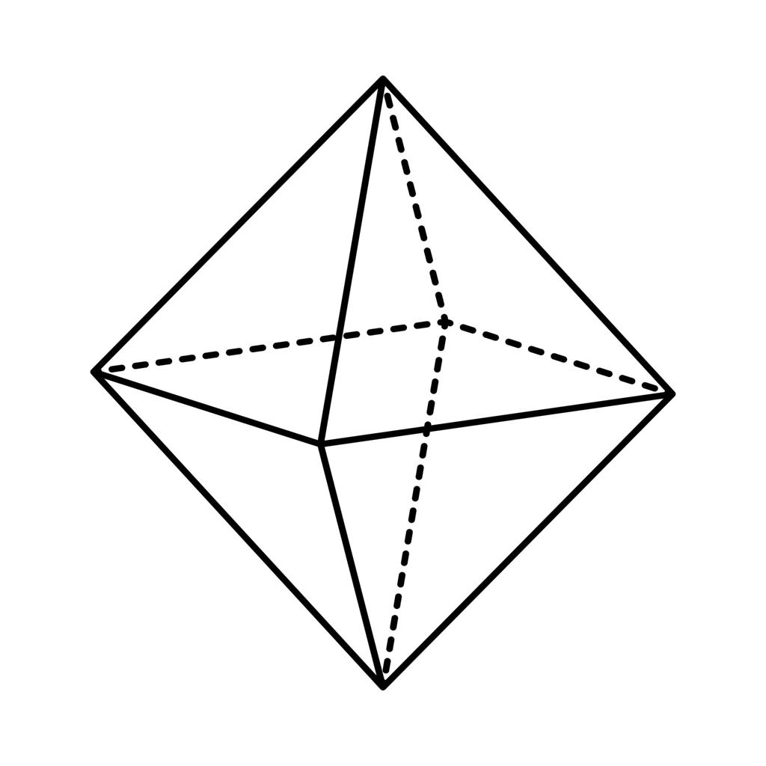
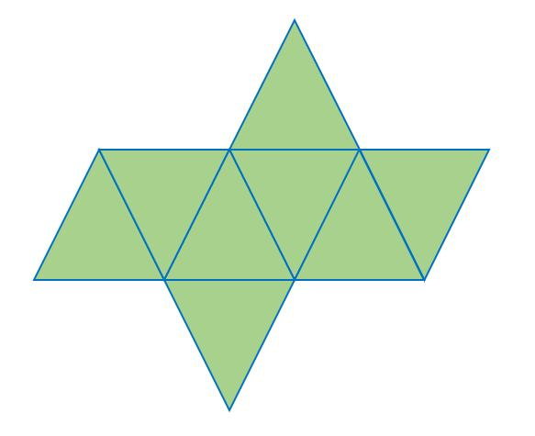

Definition
# Source: AI Source: Provided by: [Data Path: Persons Table -> ID Column: 1, Name_En Column: Motasem Essam] -> From: [ChatGPT] on [7/25/2026]
An octahedron is a three-dimensional polyhedron with eight faces, twelve edges, and six vertices. In the context of the five Platonic solids, an octahedron is a regular octahedron whose eight faces are congruent equilateral triangles.
At every vertex of a regular octahedron, four triangular faces meet. Its edges all have equal lengths, and its faces are arranged with the same geometric pattern around every vertex.
The name octahedron comes from Greek: octa means eight, and hedron means face.

Simple Definition
# Source: AI Source: Provided by: [Data Path: Persons Table -> ID Column: 1, Name_En Column: Motasem Essam] -> From: [ChatGPT] on [7/25/2026]
An octahedron is a solid with eight triangular faces, shaped like two square pyramids joined base-to-base.
For a regular octahedron:
- Faces: 8 equilateral triangles
- Edges: 12 equal line segments
- Vertices: 6 corners

Key Characteristics
# Source: AI Source: Provided by: [Data Path: Persons Table -> ID Column: 1, Name_En Column: Motasem Essam] -> From: [ChatGPT] on [7/25/2026]
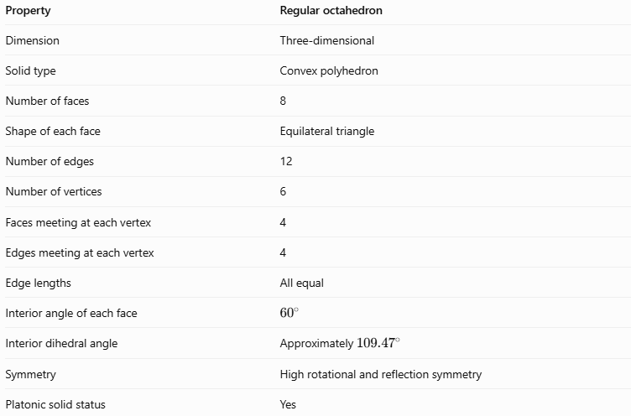
Property | Regular octahedron
Dimension | Three-dimensional
Solid type | Convex polyhedron
Number of faces | 8
Shape of each face | Equilateral triangle
Number of edges | 12
Number of vertices | 6
Faces meeting at each vertex | 4
Edges meeting at each vertex | 4
Edge lengths | All equal
Interior angle of each face | $${60}^{∘}$$
Interior dihedral angle | Approximately ${109.47}^{∘}$
Symmetry | High rotational and reflection symmetry
Platonic solid status | Yes

Geometric Representation
# Source: AI Source: Provided by: [Data Path: Persons Table -> ID Column: 1, Name_En Column: Motasem Essam] -> From: [ChatGPT] on [7/25/2026]
A regular octahedron can be understood as two square pyramids joined along their square bases, with one pyramid pointing upward and the other downward.
Faces
The eight faces are triangular. Each face is an equilateral triangle in a regular octahedron.
Edges
The twelve edges form the boundaries of the eight triangular faces. Each edge belongs to exactly two faces.
Vertices
There are six vertices:
- One at the top.
- One at the bottom.
- Four around the middle, forming a square.
Four edges and four triangular faces meet at each vertex.
Geometric structure
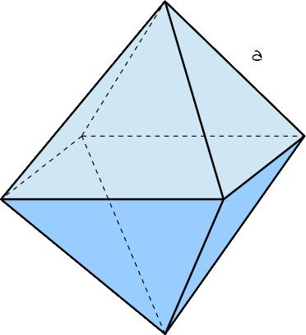
The two-pyramid representation helps explain why the octahedron has eight faces: each square pyramid contributes four triangular lateral faces, and the shared square base becomes internal rather than remaining on the exterior.

Mathematical Representations and Formulas
# Source: AI Source: Provided by: [Data Path: Persons Table -> ID Column: 1, Name_En Column: Motasem Essam] -> From: [ChatGPT] on [7/25/2026]
Let:
- $a$ = edge length
- $A_{f}$ = area of one triangular face
- $A_{T}$ = total surface area
- $V$ = volume
- $d_{s}$ = longest diagonal connecting opposite vertices

Number of faces, edges, and vertices
# Source: AI Source: Provided by: [Data Path: Persons Table -> ID Column: 1, Name_En Column: Motasem Essam] -> From: [ChatGPT] on [7/25/2026]
For a regular octahedron:
$$F=8, E=12, V_{e}=6$$
Euler's formula for convex polyhedra is:
$$V_{e}-E+F=2$$
Substituting:
$$6-12+8=2$$
Therefore, the octahedron satisfies Euler's formula.

Area of one face
# Source: AI Source: Provided by: [Data Path: Persons Table -> ID Column: 1, Name_En Column: Motasem Essam] -> From: [ChatGPT] on [7/25/2026]
Each face is an equilateral triangle:
$$\boxed{A_{f}=\frac{\sqrt{3}}{4}a^{2}}$$

Total surface area
# Source: AI Source: Provided by: [Data Path: Persons Table -> ID Column: 1, Name_En Column: Motasem Essam] -> From: [ChatGPT] on [7/25/2026]
The regular octahedron has eight congruent triangular faces:
$$A_{T}=8A_{f}$$
Therefore:
$$\boxed{A_{T}=2\sqrt{3}a^{2}}$$

Volume
# Source: AI Source: Provided by: [Data Path: Persons Table -> ID Column: 1, Name_En Column: Motasem Essam] -> From: [ChatGPT] on [7/25/2026]
A regular octahedron can be split into two equal square pyramids.
The square base area is:
$$B=a^{2}$$
The height of each pyramid is:
$$h=\frac{a}{\sqrt{2}}$$
Using the pyramid volume formula:
$$V=2\left(\frac{1}{3}Bh\right)$$
$$V=2\left({\frac{1}{3}a}^{2}\frac{a}{\sqrt{2}}\right)$$
Therefore:
$$\boxed{V=\frac{\sqrt{2}}{3}a^{3}}$$

Longest diagonal
# Source: AI Source: Provided by: [Data Path: Persons Table -> ID Column: 1, Name_En Column: Motasem Essam] -> From: [ChatGPT] on [7/25/2026]
The longest diagonal connects the top and bottom vertices, passing through the center of the solid.
$$\boxed{d_{s}=a\sqrt{2}}$$
This diagonal is twice the height of either square pyramid in the two-pyramid representation.

Radius of the circumscribed sphere
# Source: AI Source: Provided by: [Data Path: Persons Table -> ID Column: 1, Name_En Column: Motasem Essam] -> From: [ChatGPT] on [7/25/2026]
A circumscribed sphere passes through all six vertices of the regular octahedron.
Its radius is:
$$\boxed{R=\frac{a}{\sqrt{2}}}$$

Radius of the inscribed sphere
# Source: AI Source: Provided by: [Data Path: Persons Table -> ID Column: 1, Name_En Column: Motasem Essam] -> From: [ChatGPT] on [7/25/2026]
An inscribed sphere touches the eight triangular faces.
Its radius is:
$$\boxed{r=\frac{a}{\sqrt{6}}}$$

Worked Examples
# Source: AI Source: Provided by: [Data Path: Persons Table -> ID Column: 1, Name_En Column: Motasem Essam] -> From: [ChatGPT] on [7/25/2026]
Example 1: Counting geometric elements
Problem: How many faces, edges, and vertices does a regular octahedron have?
Solution:
- Faces: $F=8$
- Edges: $E=12$
- Vertices: $V_{e}=6$
Check Euler's formula:
$$6-12+8=2$$
Answer: 8 faces, 12 edges, and 6 vertices.
Example 2: Calculating total surface area
Problem: A regular octahedron has an edge length of $4\text{ cm}$. Find its total surface area.
Formula:
$$A_{T}=2\sqrt{3}a^{2}$$
Substitution:
$$A_{T}=2\sqrt{3}{\left(4\right)}^{2}$$
$$A_{T}=32\sqrt{3}$$
$$\boxed{A_{T}≈55.43{\text{ cm}}^{2}}$$
Example 3: Calculating volume
Problem: Find the volume of a regular octahedron with an edge length of $3\text{ cm}$.
Formula:
$$V=\frac{\sqrt{2}}{3}a^{3}$$
Substitution:
$$V=\frac{\sqrt{2}}{3}{\left(3\right)}^{3}$$
$$V=9\sqrt{2}$$
$$\boxed{V≈12.73{\text{ cm}}^{3}}$$
Example 4: Finding the longest diagonal
Problem: A regular octahedron has an edge length of $6\text{ cm}$. Find its longest diagonal.
Formula:
$$d_{s}=a\sqrt{2}$$
Substitution:
$$d_{s}=6\sqrt{2}$$
$$\boxed{d_{s}≈8.49\text{ cm}}$$
Example 5: Finding the edge length from the volume
Problem: A regular octahedron has a volume of $24\sqrt{2}{\text{ cm}}^{3}$. Find its edge length.
Formula:
$$V=\frac{\sqrt{2}}{3}a^{3}$$
Rearrange:
$$a^{3}=\frac{3V}{\sqrt{2}}$$
Substitute:
$$a^{3}=\frac{3\left(24\sqrt{2}\right)}{\sqrt{2}}=72$$
Therefore:
$$\boxed{a=\sqrt[3]{72}≈4.16\text{ cm}}$$

Comparison with Related Geometric Solids
# Source: AI Source: Provided by: [Data Path: Persons Table -> ID Column: 1, Name_En Column: Motasem Essam] -> From: [ChatGPT] on [7/25/2026]
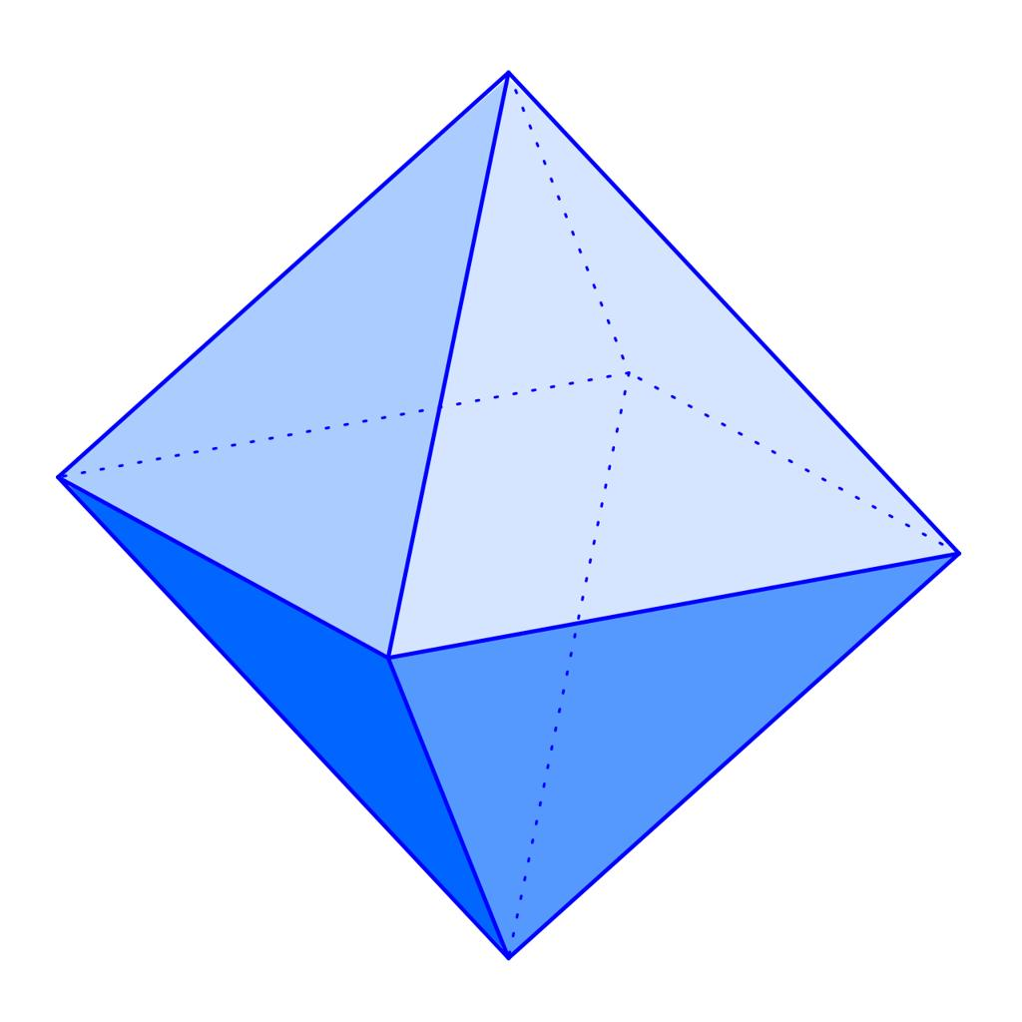
Octahedron
8 faces · 12 edges · 6 vertices
A regular octahedron has eight equilateral-triangle faces and four faces meeting at every vertex.
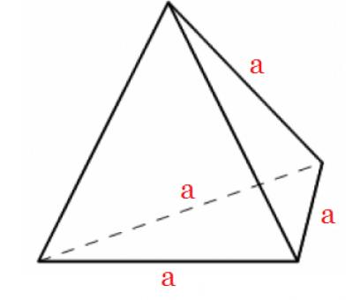
Tetrahedron
4 faces · 6 edges · 4 vertices
Has four equilateral-triangle faces, with three faces meeting at each vertex.
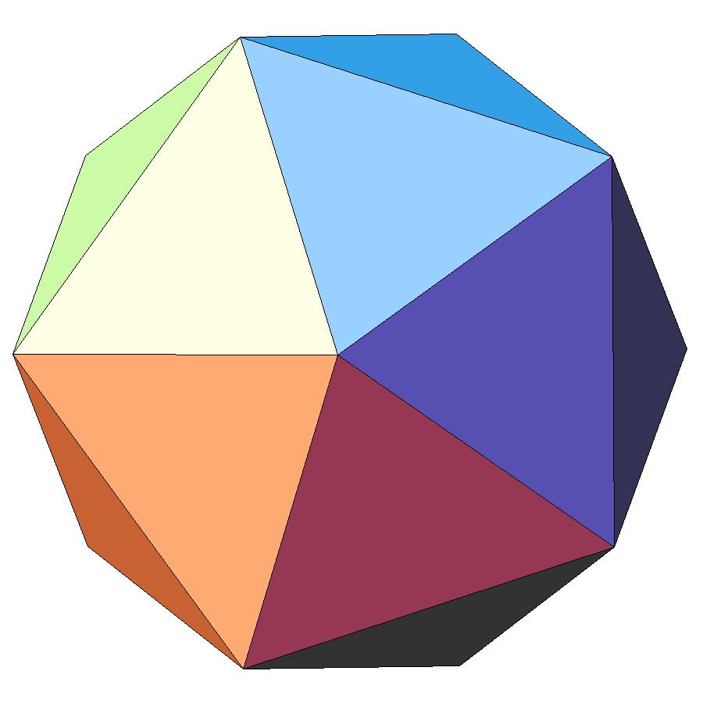
Icosahedron
20 faces · 30 edges · 12 vertices
Also has equilateral-triangle faces, but it has more faces and vertices than the octahedron.
The octahedron and tetrahedron both have triangular faces, but their structures differ. The octahedron has twice as many faces as the tetrahedron and six vertices rather than four.

The Octahedron Among the Five Platonic Solids
# Source: AI Source: Provided by: [Data Path: Persons Table -> ID Column: 1, Name_En Column: Motasem Essam] -> From: [ChatGPT] on [7/25/2026]
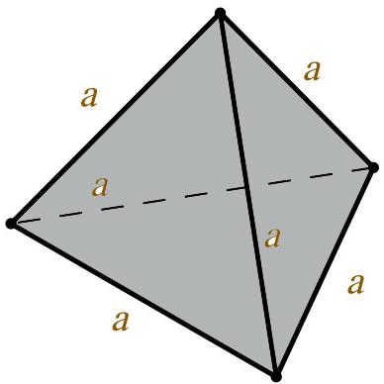
1. Tetrahedron
4 triangular faces
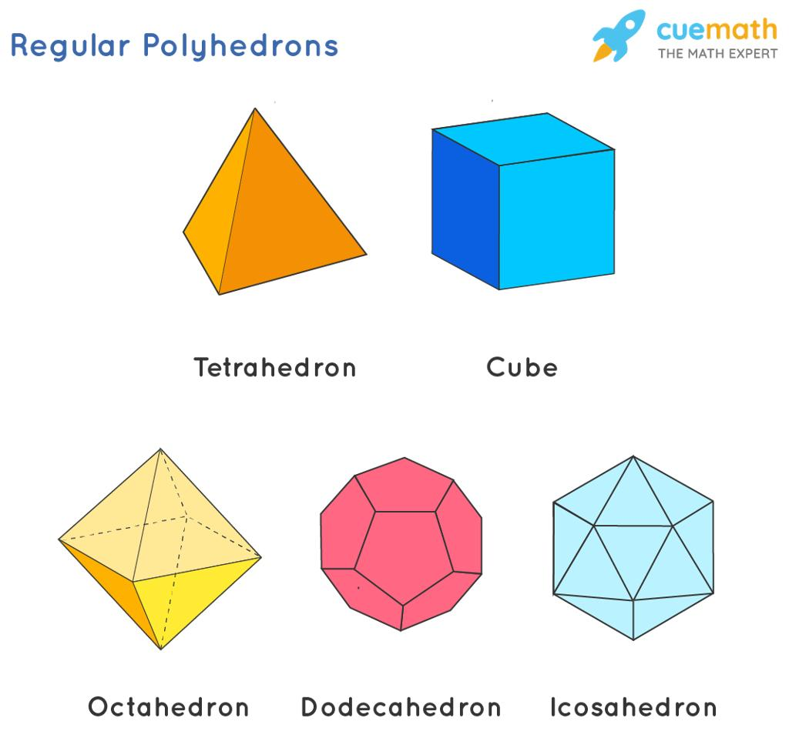
2. Cube (Hexahedron)
6 square faces
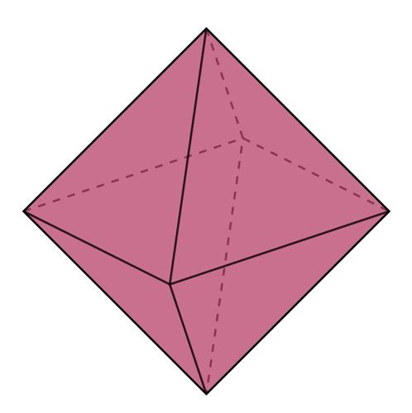
3. Octahedron
8 triangular faces
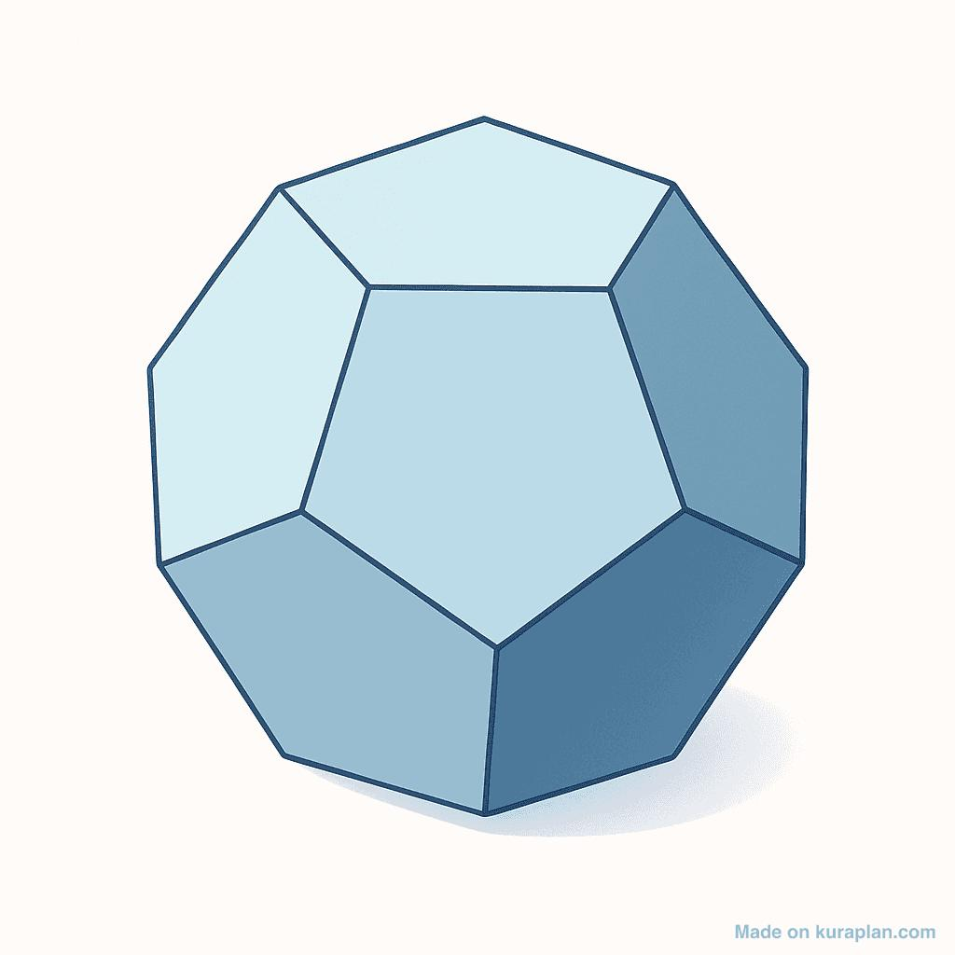
4. Dodecahedron
12 pentagonal faces
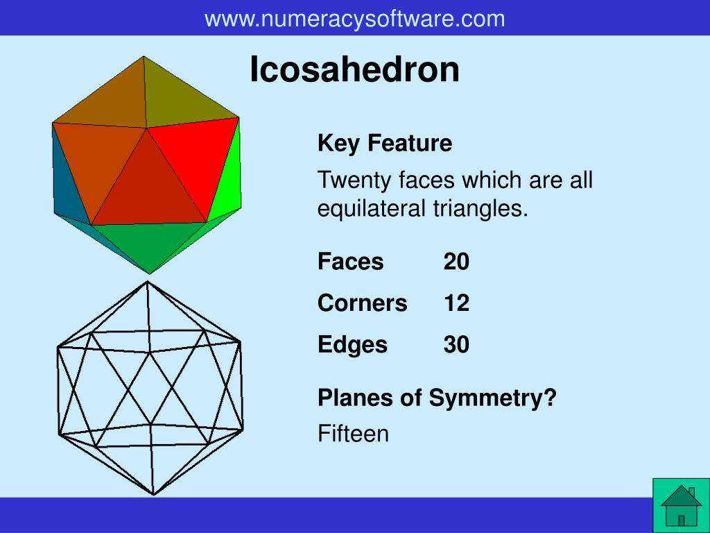
5. Icosahedron
20 triangular faces
The octahedron is the third solid in this list. Its eight faces make it more complex than the tetrahedron and cube in terms of face count, while retaining highly regular symmetry.

Constructing Octahedron in Solid Geometry

Instruments Used
# Source: AI Source: Provided by: [Data Path: Persons Table -> ID Column: 1, Name_En Column: Motasem Essam] -> From: [ChatGPT] on [7/25/2026]
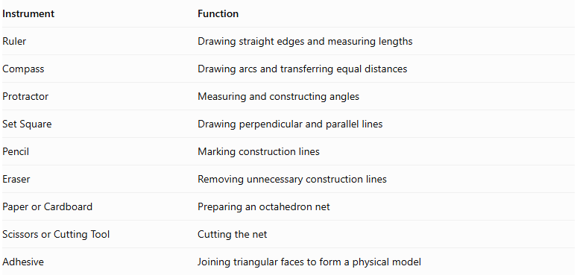
Instrument | Function
Ruler | Drawing straight edges and measuring lengths
Compass | Drawing arcs and transferring equal distances
Protractor | Measuring and constructing angles
Set Square | Drawing perpendicular and parallel lines
Pencil | Marking construction lines
Eraser | Removing unnecessary construction lines
Paper or Cardboard | Preparing an octahedron net
Scissors or Cutting Tool | Cutting the net
Adhesive | Joining triangular faces to form a physical model

Construction Procedures

A. Face-Based Construction
# Source: AI Source: Provided by: [Data Path: Persons Table -> ID Column: 1, Name_En Column: Motasem Essam] -> From: [ChatGPT] on [7/25/2026]
- Draw an equilateral triangle using a ruler and compass.
- Construct the remaining triangular faces using the same edge length.
- Arrange four triangular faces around one central region to form one half of the octahedron.
- Construct the corresponding four triangular faces for the opposite half.
- Join the corresponding edges of both halves.
- Verify that all eight faces are equilateral triangles.
- Darken the visible edges and distinguish hidden edges.
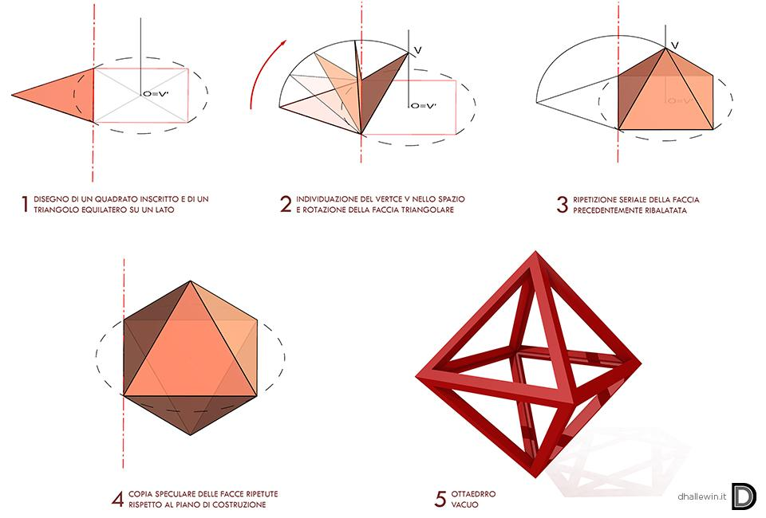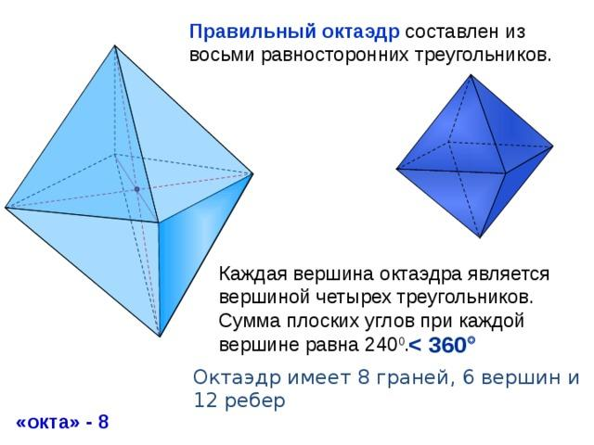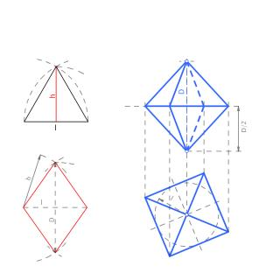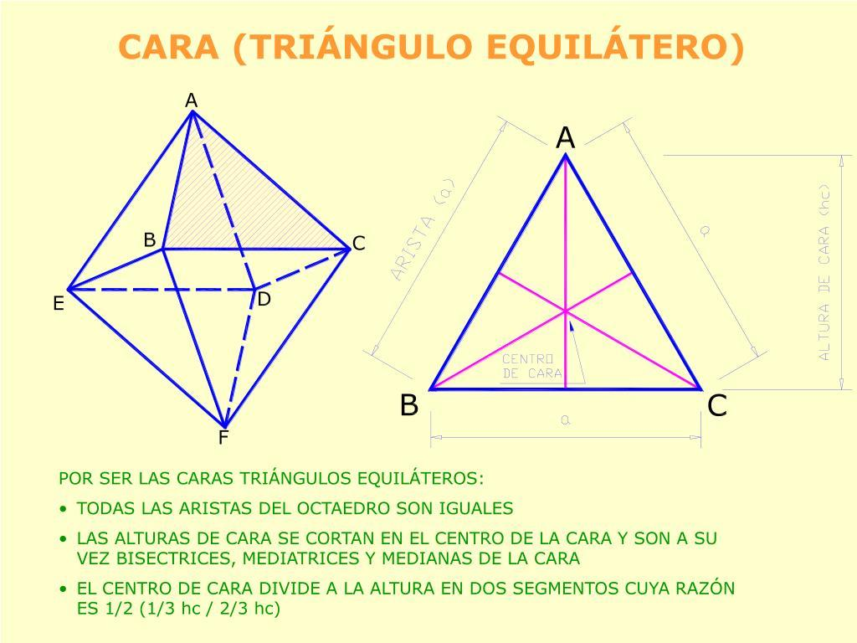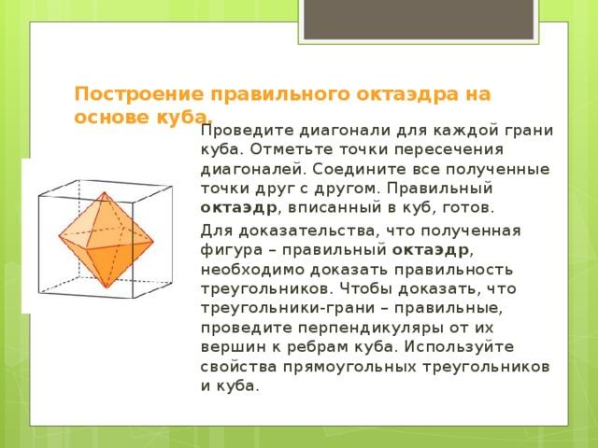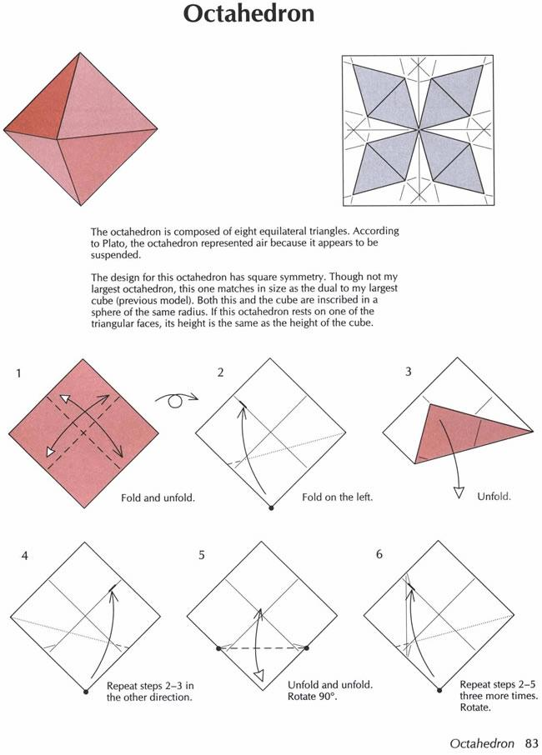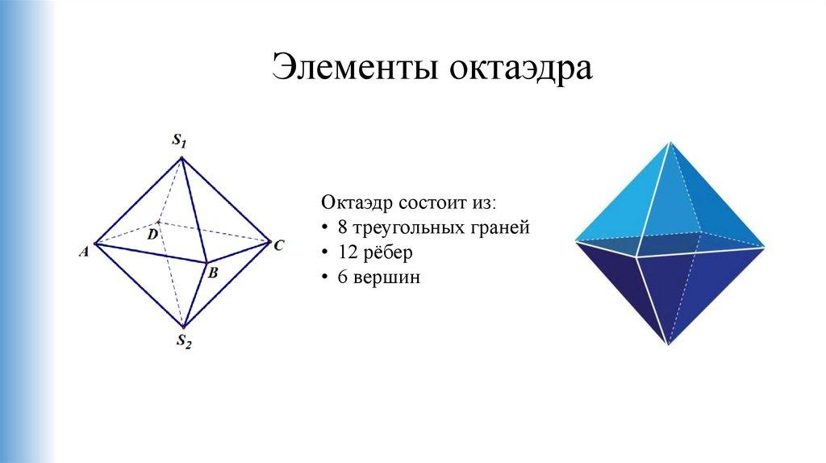

B. Edge-Based Construction
# Source: AI Source: Provided by: [Data Path: Persons Table -> ID Column: 1, Name_En Column: Motasem Essam] -> From: [ChatGPT] on [7/25/2026]
- Determine the required edge length.
- Construct the twelve edges with equal lengths.
- Arrange the edges to form two square pyramidal halves joined at their square bases.
- Ensure that each half has four triangular lateral faces.
- Connect the corresponding vertices of both halves.
- Verify that the completed structure contains eight triangular faces.

C. Vertex-Based Construction
# Source: AI Source: Provided by: [Data Path: Persons Table -> ID Column: 1, Name_En Column: Motasem Essam] -> From: [ChatGPT] on [7/25/2026]
- Establish the six vertices of the octahedron.
- Arrange them into three pairs of opposite vertices.
- Identify the four vertices surrounding each opposite-vertex pair.
- Connect the appropriate vertices to form the twelve edges.
- Complete the eight triangular faces.
- Identify the hidden edges where necessary.

D. Diagonal-Based Construction
# Source: AI Source: Provided by: [Data Path: Persons Table -> ID Column: 1, Name_En Column: Motasem Essam] -> From: [ChatGPT] on [7/25/2026]
- Construct three equal-length segments representing the three space diagonals.
- Arrange the segments so that they intersect at their common midpoint.
- Ensure that the three diagonals are mutually perpendicular.
- Mark the six endpoints as the six vertices.
- Connect the appropriate endpoints to form the twelve edges.
- Complete the eight triangular faces.

E. Net-Based Construction
# Source: AI Source: Provided by: [Data Path: Persons Table -> ID Column: 1, Name_En Column: Motasem Essam] -> From: [ChatGPT] on [7/25/2026]
- Draw eight congruent equilateral triangles.
- Arrange the triangles in one of the eleven distinct octahedron-net arrangements.
- Add joining tabs if preparing a physical model.
- Cut out the net.
- Fold along the shared edges.
- Join the corresponding edges.
- Complete the eight-faced octahedron.
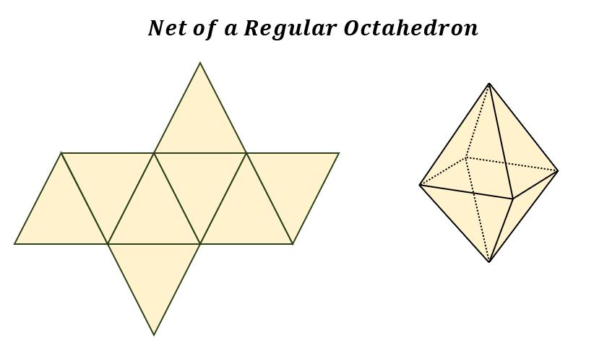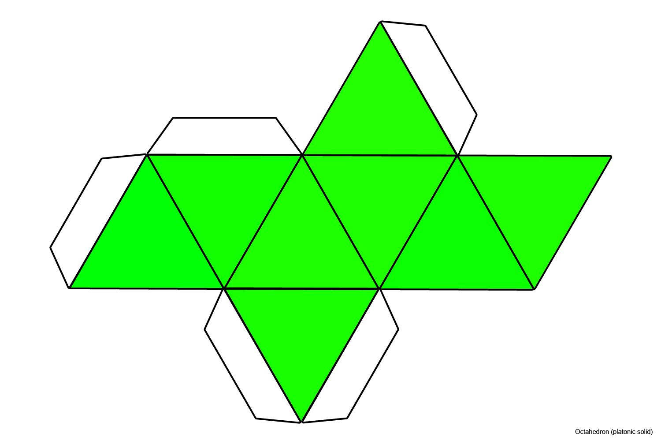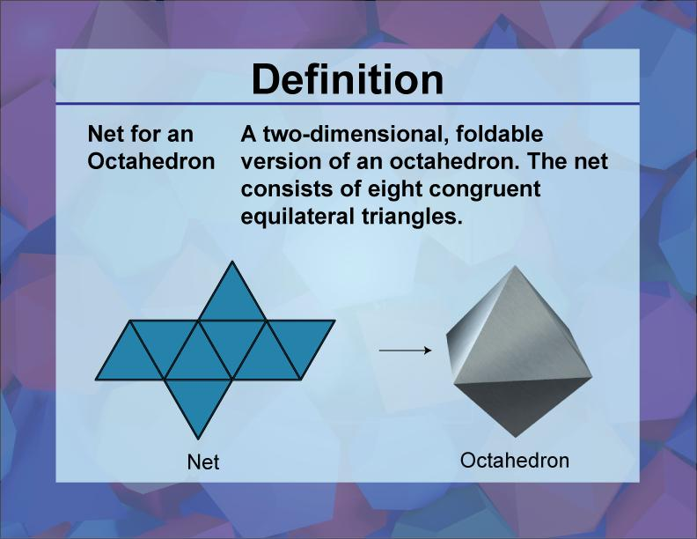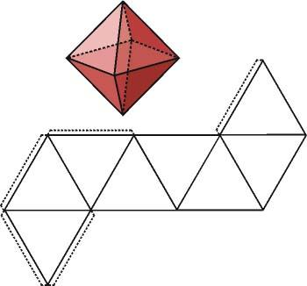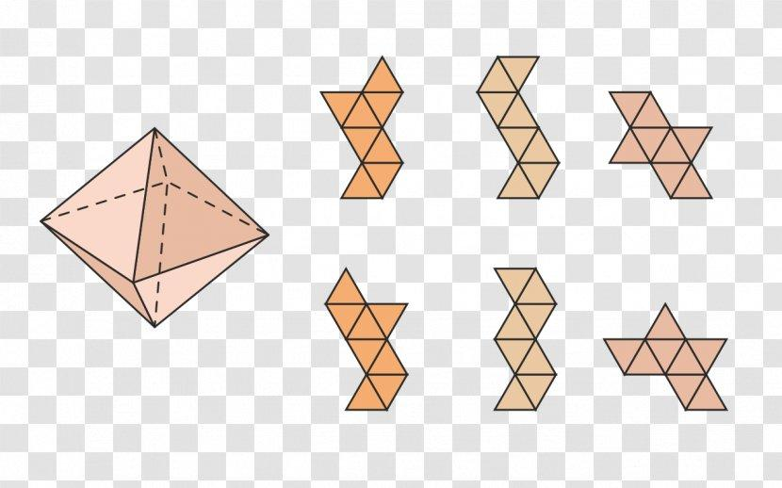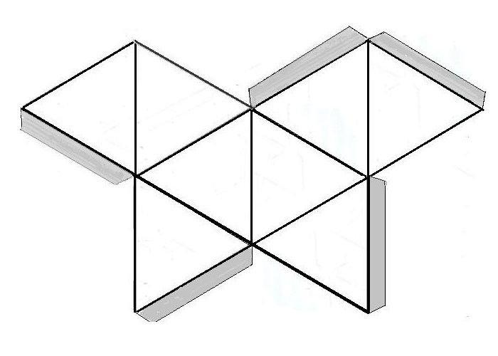

F. Physical Model Construction
# Source: AI Source: Provided by: [Data Path: Persons Table -> ID Column: 1, Name_En Column: Motasem Essam] -> From: [ChatGPT] on [7/25/2026]
- Prepare eight congruent equilateral triangular pieces or a suitable octahedron net.
- Measure and cut all triangular pieces to equal dimensions.
- Arrange four triangular faces around one half of the model.
- Construct the opposite half using the remaining four faces.
- Join the corresponding edges of both halves.
- Verify that the completed model has six vertices and twelve equal edges.

Applications of the Octahedron
# Source: AI Source: Provided by: [Data Path: Persons Table -> ID Column: 1, Name_En Column: Motasem Essam] -> From: [ChatGPT] on [7/25/2026]
- Crystallography: octahedral arrangements appear in the structures of some crystals and coordination compounds.
- Chemistry: six ligands can surround a central atom in an octahedral molecular geometry.
- Architecture and engineering: octahedral forms can be used in geometric frameworks and structural models.
- Mathematics education: the octahedron illustrates polyhedral symmetry, diagonals, and Euler's formula.
- Computer graphics: octahedra are used in 3D modeling, mesh construction, and geometric simulations.
- Games and models: octahedron-shaped dice and educational solids demonstrate three-dimensional geometry.

Key Points
# Source: AI Source: Provided by: [Data Path: Persons Table -> ID Column: 1, Name_En Column: Motasem Essam] -> From: [ChatGPT] on [7/25/2026]
- An octahedron is a polyhedron with eight faces.
- A regular octahedron is one of the five Platonic solids.
- It has 8 equilateral-triangle faces, 12 equal edges, and 6 vertices.
- Four faces and four edges meet at each vertex.
- Total surface area: $A_{T}=2\sqrt{3}a^{2}$.
- Volume: $V=\frac{\sqrt{2}}{3}a^{3}$.
- Longest diagonal: $d_{s}=a\sqrt{2}$.
- It can be represented as two square pyramids joined at their bases.
- It satisfies Euler's formula: $V_{e}-E+F=2$.

Conclusion
# Source: AI Source: Provided by: [Data Path: Persons Table -> ID Column: 1, Name_En Column: Motasem Essam] -> From: [ChatGPT] on [7/25/2026]
The octahedron is one of the five Platonic solids and is distinguished by its eight congruent equilateral-triangle faces. Its twelve equal edges, six vertices, and four faces meeting at each vertex give it a highly symmetrical structure. Understanding the octahedron strengthens knowledge of polyhedra, surface area, volume, symmetry, and the relationships between three-dimensional geometric solids.

